**Prelab-Week-10**

**Prelab Questions:**

1. Write the control abstraction for Backtracking design strategy
2. Write the algorithm to place ‘n’ queens on a N X N chess board
3. What is Chromatic number? Give an example.
4. Draw the state space tree to color the following graph

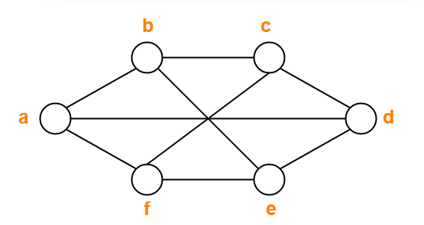

1. What is Hamiltonian cycle? Give an example

**Prelab Programs:**

1. Implement of N-queens problem with Back tracking.
2. Implement Graph coloring problem with back tracking